In Am Fuchsberg, in the lower timed transition, how do we define which car goes to which state? There should be another intermediary state here, or as Arnab suggested, three timed transitions instead of two. But I understand that the setting below simulates the two-line idea, so I like it this way. Maybe we add an intermediate state and then assign probabilities to either go forward or turn right.

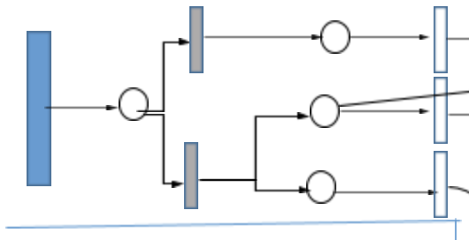

In the case below, what is the role of the second state? Can’t we have a direct timed transition in the first state?

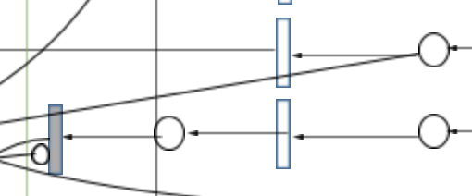

I think that here we also need a way of determining whether the points on the state will move forward or turn right.

